**Jenkins with ansible:**

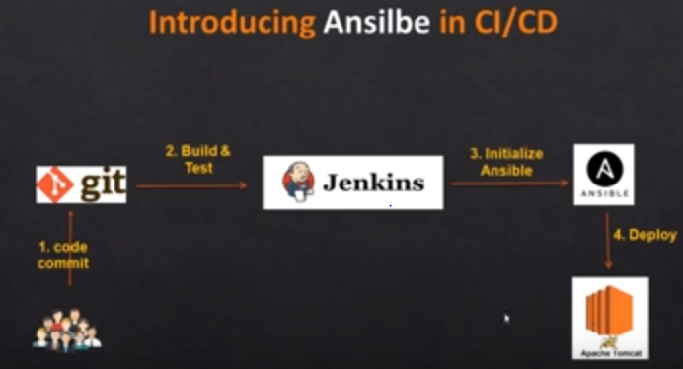

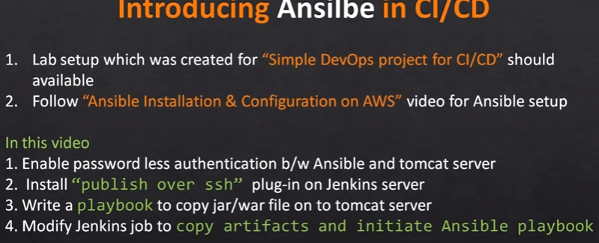

* We need to have 3 servers



* Create password less authentication
* Install publish over ssh plugin in Jenkins. Then write an yml file in ansible server top copy the war file to tomcat server’s webapps folder

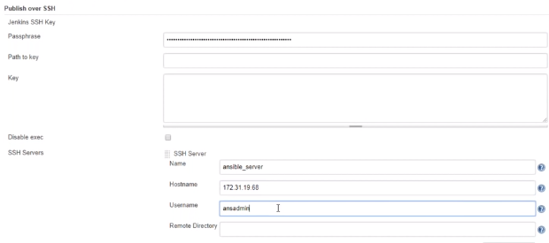

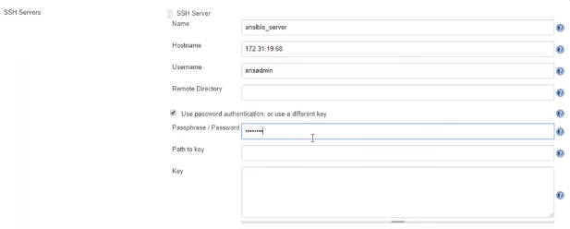

* Better use the password-based authentication as above to the ansible server, if we use key some one might take it and miss use it
* We can test the configuration once the configuration is done

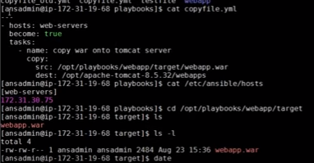

* Configure ansible server with publish over SSH
* Inside job, we have to configure the post build step as send files or execute commands over SSH
* Then give source file location and remote directory location where we want to copy the file as below

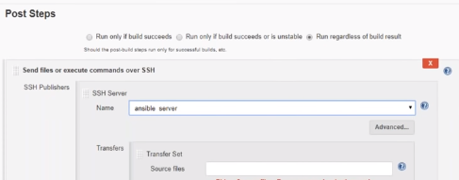

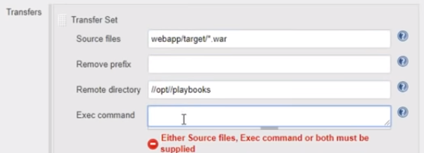

* And create one more build step with the command to run playbook as below
* It is not good practice to do these two tasks under one build step. Sometimes it might not work. So, create two build steps

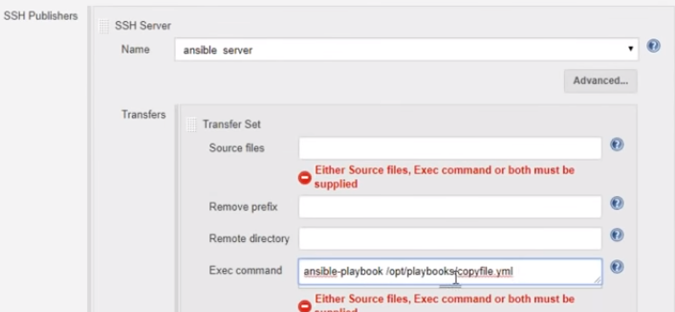

* Now, if we build this job, war file will be copied into the ansible server and then from there it will copied to tomcat server